Deontology

Definition for laypersons:
In the following, we want to ask you to evaluate the [Stratospheric Aerosol Injection] technology to see whether it violates central principles or duties

Deontology is concerned with the possible violation of central principles or duties:
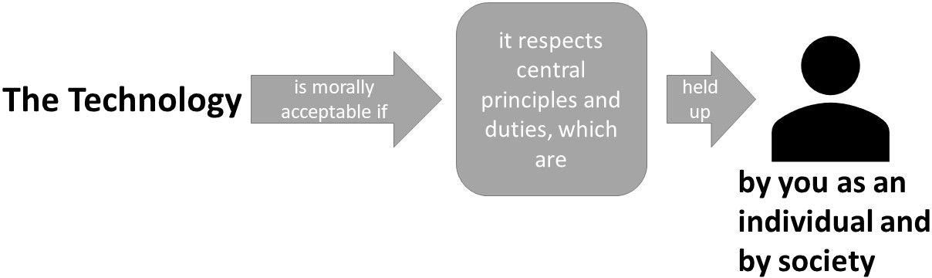
A technology is morally acceptable if it respects basic principles and duties. These basic principles are held up by you as a free and rational person. Your principles are oriented by the guiding statement: "You should act the way you want others to act". When interacting with the technology, upholding your principles is of central importance, not the potential outcomes and consequences of your actions.

Utilitarianism

Definition for laypersons:
In the following we want to ask you to evaluate the [Stratospheric Aerosol Injection] technology regarding its consequences on society

Utilitarianism is concerned with the consequences for society:

A technology is morally acceptable if it leads to the best outcomes and consequences for society. By interacting with the technology, society aims to maximize overall benefit by increasing utility, decreasing harm or leading to a better world.

Hedonism

Definition for laypersons:
In the following we want to ask you to evaluate the [Stratospheric Aerosol Injection] technology regarding its consequences for you personally

Hedonism is concerned with the consequences for you personally:

A technology is morally acceptable if it increases pleasure and wellbeing or promotes a good life for you. By interacting with the technology in an instrumental way, you can increase your pleasure, wellbeing or your personal goals.

Virtue ethics

Definition for laypersons:
In the following we want to ask you to evaluate the [Stratospheric Aerosol Injection] technology regarding the moral standards of the person who has developed this technology

Virtue ethics is concerned with the moral standards of the technology’s developer:
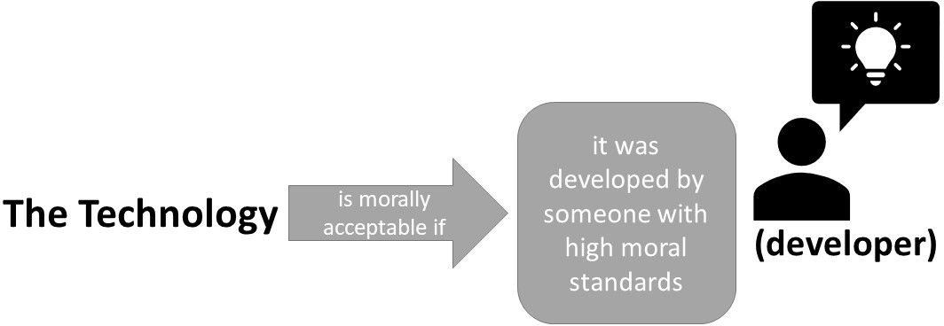
A technology is morally acceptable if it has been developed by someone who has the character and ability to recognize what is morally required. The developer is an upright person with high moral standards, who has developed the technology on the basis of her/his values.

Contractualism

Definition for laypersons:
In the following we want to ask you to evaluate the [Stratospheric Aerosol Injection] technology in terms of whether it goes against implicit conventions upon which our society generally relies

Contractualism asks whether implicit conventions upon which our society generally relies are disregarded or violated:

A technology is morally acceptable if it does not disregard or work against implicit moral conventions that are considered essential to the functioning of a society. To not break moral conventions is in the best interest of all members of a society. For example, in a state where there is “war of all against all”, life would be too insecure and harmful.

Relativism

Definition for laypersons:
In the following we want to ask you to evaluate the [Stratospheric Aerosol Injection] technology regarding the possibility that the ethical evaluation differs between groups of people

Relativism is concerned with the possibility that ethical evaluation differs between groups of people:
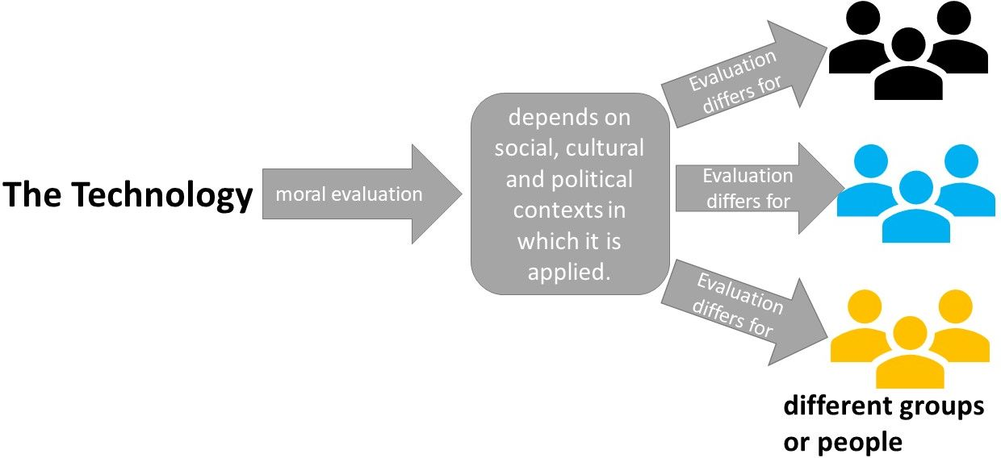
The acceptability of a technology depends on the social, cultural and political contexts in which it is applied. These different contexts influence the standards and procedures by which the use or implementation of a technology are justified.

